**Small-World Networks Induce Seemingly Low-Dimensional Psychology Under Constrained Stimuli**

Junsong Lu1*, Chujun Lin2

1 Department of Psychology, University of California San Diego, La Jolla, U.S.

2 Department of Psychology, Columbia University, New York, U.S.

**Author Note**

Junsong Lu  <https://orcid.org/0000-0001-6987-6228>

Chujun Lin  https://orcid.org/0000-0002-7605-6508

The authors have no conflict of interest to disclose.

*Corresponding author *E-mail address*: jul140@ucsd.edu

# **Abstract**

Research in social cognition has long emphasized low-dimensional models, suggesting that people perceive social behaviors using broad evaluative dimensions (e.g., warmth). However, emerging evidence from naturalistic settings reveals that social judgments are far more complex and high-dimensional. To reconcile these findings, we propose a novel perspective: trait inferences—and potentially broader forms of social knowledge—are represented as a growing network with small-world properties. The small-world topology implies that nodes are surprisingly close to one another, allowing activation to spread efficiently across the network. Constrained stimuli (e.g., isolated faces) activate only a small subset of nodes, whose signals then propagate consistently across the network, producing the appearance of low dimensionality. We demonstrated how this network account can reinterpret classic findings, including the beauty-is-good effect and dimensional models, as emergent properties under constrained input. We advocated for a shift beyond low-dimensional paradigms to better capture the complexity of human social cognition. (150/150)

***Keywords***: social perception, social cognition, network analysis, computational modeling, naturalistic design

# **Introduction**

In social cognition, researchers have long sought to understand how people perceive, categorize, and judge both their own behavior and that of others 1–4. In terms of Marr's level of analysis, this inquiry addresses the “How” question of social cognition5. Traditionally, answers to this question have been dominated by low-dimensional models6–11, which assume that mental representations of social behavior are relatively low in complexity, functioning as mental shortcuts. For instance, when people infer someone’s personality traits or social category based on perceptual cues like facial appearance, they often rely on a limited number of evaluative dimensions like “warmth”, “competence”, “femininity”, and “youth”12.

The low-dimensional perspective in social cognition emerged from two major lines of research spanning over fifty years. First, the beauty-is-good halo effect illustrated that a single attribute—physical attractiveness—predicts judgments of intelligence, health, and moral character, suggesting that perceivers condense information into a broad evaluative dimension13–17. Second, foundational studies on trait perception demonstrated that a small number of latent factors account for a wide range of inferences, from personality traits and emotional judgments to stereotypes and facial attributions4,6–9,12,18. Despite the lasting influence of these low-dimensional models, a growing body of evidence points toward a high-dimensional view of social cognition19–29. For example, naturalistic stimuli have revealed up to 27 distinct dimensions of emotions25. Comparable high-dimensional findings have emerged in trait perception27, stereotypes29, aesthetics24, and expression recognition26.

To reconcile these divergent findings, we introduced a novel perspective on trait inference and potentially broader domains of social cognition. We propose that mental representations of social knowledge, such as traits, form a small-world network structure shaped by a specific growth pattern. In these networks, numerous nodes are preserved while remaining in close proximity, giving rise to the appearance of low-dimensional structure when constrained stimuli are used. This network framework not only accounts for prior findings in trait perception but also generalizes to multiple social cognitive domains.

The current perspective is developed in four sections. First, we briefly reviewed previous findings on both low- and high-dimensional psychology across various domains in social cognition, focusing on the beauty-is-good effect and psychological dimensions. Second, based on these findings, we introduced the network model. This section addresses three key aspects of the network: the structure of abstract social knowledge, the processes that operate on the network, and how structure and process interact under environmental input. Simulation data is presented for accessibility while more detailed mathematical proof can be found in supplementary materials. We accessed the plausibility of this network structure by discussing related neural, developmental, and cross-cultural studies. Third, we reinterpret prior low-dimensional findings as emergent effects of small-world properties under constrained stimuli. Finally, we advocate for moving beyond the current low-dimensional paradigm to gain a better understanding of social cognition.

# **The Low- and High-Dimensional Accounts of Person Perception**

To illustrate the low-dimensional account, we reviewed two lines of research that have shaped the field for over 50 years. The first line is the beauty-is-good halo effect. The second stream is the dimensional models of person perception.

## **The Beauty-is-Good Effect and the Dimensional Models**

The landmark study of the beauty-is-good effect dates back to 1972, when Dion and colleagues demonstrated that people tend to attribute positive qualities (e.g., socially desirable) to physically attractive individuals. In a typical task, participants watch face images vary in attractiveness and rate them across multiple traits. Subsequent research, including large-scale meta-analytic reviews in the 1990s, confirmed the robustness and prevalence of this effect. Notably, Eagjy et al.14 demonstrated that the effect is more pronounced in interpersonal domains (e.g., sociability) and weaker in domains like intelligence and integrity. Further debates emerged around whether this effect reflects any ground truth. While meta-analyses reported minimal correlations between attractiveness and measured traits16, some anecdotal links were found17,30–33, particularly in intelligence and health. Among the numerous traits that may be affected by attractiveness, intelligence and health have received particular research focus17,34–37. One evolutionary explanation, the good genes hypothesis, posits that facial attractiveness may signal genetic fitness, including higher intelligence and better health38. Building on this, Zebrowitz and colleagues proposed the face overgeneralization hypothesis17,39,40: although facial attractiveness may correlate with certain traits at lower ranges of facial quality, perceivers generalize this limited validity across the full spectrum, giving rise to the beauty-is-good effect. More recent research supports this interpretation, reaffirming the effect’s prevalence despite weak associations with actual traits41–43. Collectively, these findings suggest that trait inferences are often driven by overly simplified heuristics.

While the attractiveness halo effect focuses on a single association, another major stream of research examines the overall structure of trait associations, or more broadly, the structure of social cognition. A long-standing tradition holds that social inferences are organized within a low-dimensional latent space, where each inference reflects a combination of a few underlying psychological constructs. This search for psychological dimensions dates back to Asch’s seminal work on impression formation in 194644. By asking participants to describe a person based on a list of traits, Asch found that certain traits (e.g., “warm” vs. “cold”) dramatically shaped overall impressions, highlighting their central role. Reanalyzing these data, Wishner45 showed that a trait’s impact depends on its intercorrelations with other traits. Traits with higher correlations exert greater influence, thus supporting the use of dimensional reduction techniques like factor analysis to identify the source of variations in social inferences. Building on this, Rosenberg et al.11 identified two to three dimensions (e.g., sociality and intellectual desirability) that summarize trait inferences. Subsequent investigations continued the search of dimensions in social cognition, with two dimensions (the Big Two model) recurrently emerge across domains and decades4,46–50. For instance, the warmth and competence dimensions underlie stereotypes toward social groups4. Many studies have also found a few more factors, such as three dimensions for social judgment51,52, four factors of face attributions12, and the five-dimensional latent space of personality6.

Despite variations in the number and interpretation of identified dimensions, most studies converge on the finding that a small number of dimensions explain the majority of variance in behavioral measures53. While these dimensions can be viewed as statistical summaries of social cognition, commonly used methods such as factor analysis suggest the existence of unobservable yet meaningful latent constructs. Notably, the widely replicated Big Two dimensions, warmth and competence, are thought to reflect perceptions of others’ intentions and their ability to act on those intentions4,8. These dimensions are often considered evolutionarily adaptive and fundamental to person perception8,54,55. Similar evolutionary interpretations have been proposed for other factors, such as attractiveness7,34. Furthermore, the appeal of low-dimensional models is often justified by cognitive constraints: they offer an efficient way for the mind to simplify and manage complex social environments56,57.

## **Empirical Findings Supporting High-Dimensional Social Cognition**

In contrast to the low-dimensional account, recent advances in social cognition support a high-dimensional perspective on person perception. These studies challenge the notion that a few factors are sufficient to capture the complexity of social judgments. For example, using open-ended methods, Nicolas and colleagues identified 40 distinct dimensions derived from participants’ free descriptions of social groups, including morality, sociability, and ability.

The more recent work shares two key features. First, rather than specifying a few factors and predefining a few items for measurements, researchers now use more diverse item sets and response formats20,23,58. For instance, Brooks et al.22 asked participants to rate 4,659 face images on 48 emotions and mental states. Analyses based on a deep neural network revealed 28 facial expression dimensions. Second, rather than using cropped faces or short verbal descriptions used in prior studies, these studies employ more naturalistic stimuli ranging from realistic images to videos that convey richer multisensory information. For example, Cowen and Keltner25 used 2,185 video clips depicting emotionally significant events (e.g., weddings) and identified 27 distinct emotion dimensions from elicited emotional responses.

These findings suggest that prior reliance on constrained stimuli may have limited the recovery of psychological dimensions. When richer, multimodal input is available, the mind may integrate cues based on their reliability59, leading to the emergence of more—and different—dimensions. Indeed, even cues not directly relevant to the judgment can influence perception by shaping the use of predictive information60.

While most recent studies still adopt a dimensional perspective, emerging evidence also suggests that this framework may be insufficient. For example, Connor et al. identified 14 dimensions of social attributions based on naturalistic face images. However, these latent factors only explained 38% of the variance in the data, contrasting with 60-80% explained variance in prior studies8,12. Similarly, Lu and Lin20 found that a 25-factor model accounted for less than 15% of the variance in impression ratings based on naturalistic videos. In the same study, the authors compared this dimensional model with a sparse network model61,62, which treated each descriptive response as a unique variable without assuming underlying latent factors. The network model demonstrated a better fit to the data, suggesting that in naturalistic contexts, social cognition may be more accurately captured by non-dimensional representations.

In summary, the stark contrast between low- and high-dimensional accounts calls for a reexamination of the underlying structure of mental representations underlying social cognition. While increasing the number of dimensions may improve data fit, it remains unclear how these representations emerge and how they interact with environmental input. In highly complex, naturalistic settings where dimensionality is high, it may be necessary to explore alternative representational frameworks that better reflect human cognitive architecture.

# **A Growing Network Model of Social Cognition**

## **The Network Structure Processing, and Their Interactions**

Cognitive scientists have long viewed the mind as inherently associative and thus understanding the mind requires the investigation of mental processing operating over a network structure 63,64. Early work in this domain emerged from network models of semantic memory. In their seminal study, Collins and Quillian65 proposed that concepts are represented as nodes within a hierarchical tree structure. While elegant, this model is best suited to taxonomically organized knowledge (e.g., animal categories) and does not easily generalize to other mental domains such as color perception, face recognition, or social relationships66,67.

Several disjointed fields from sociology and physics provided additional insights on network structure. In the early 1960s, sociologist de Sola Pool and mathematician Kochen introduced the concept of “small world” in their analysis of social connections68. Their manuscript has been widely circulated and inspired the famous small-world experiment by Milgram69. The central idea, popularized by playwright John Guare as “six degrees of separation,” posits that anyone in a social network can be reached through a few intermediary connections. Meanwhile, in a separate line of work unknown to sociologists at the time, Erdős and Rényi developed a random graph model70. They showed that as the average degree of connectivity (the number of links of a node) increases, a giant component emerges in which most nodes become interconnected. This structure supports the small-world property by drastically reducing the network’s maximum distance between any two nodes. As a result, this maximum distance, or diameter of the network, becomes negligible in terms of the size of the network (e.g., number of nodes).

In real-world systems, nodes, ranging from conceptual representations to individuals in social networks, are not connected randomly71–73. Unlike random networks that follow a Poisson degree distribution, real-world networks often exhibit a power-law distribution: a few nodes have many connections, while most have few. This scale-free architecture emerges from two fundamental mechanisms: growth, whereby networks expand by adding new nodes, and preferential attachment, where new nodes are more likely to connect with already well-connected ones71 (Figure 1).

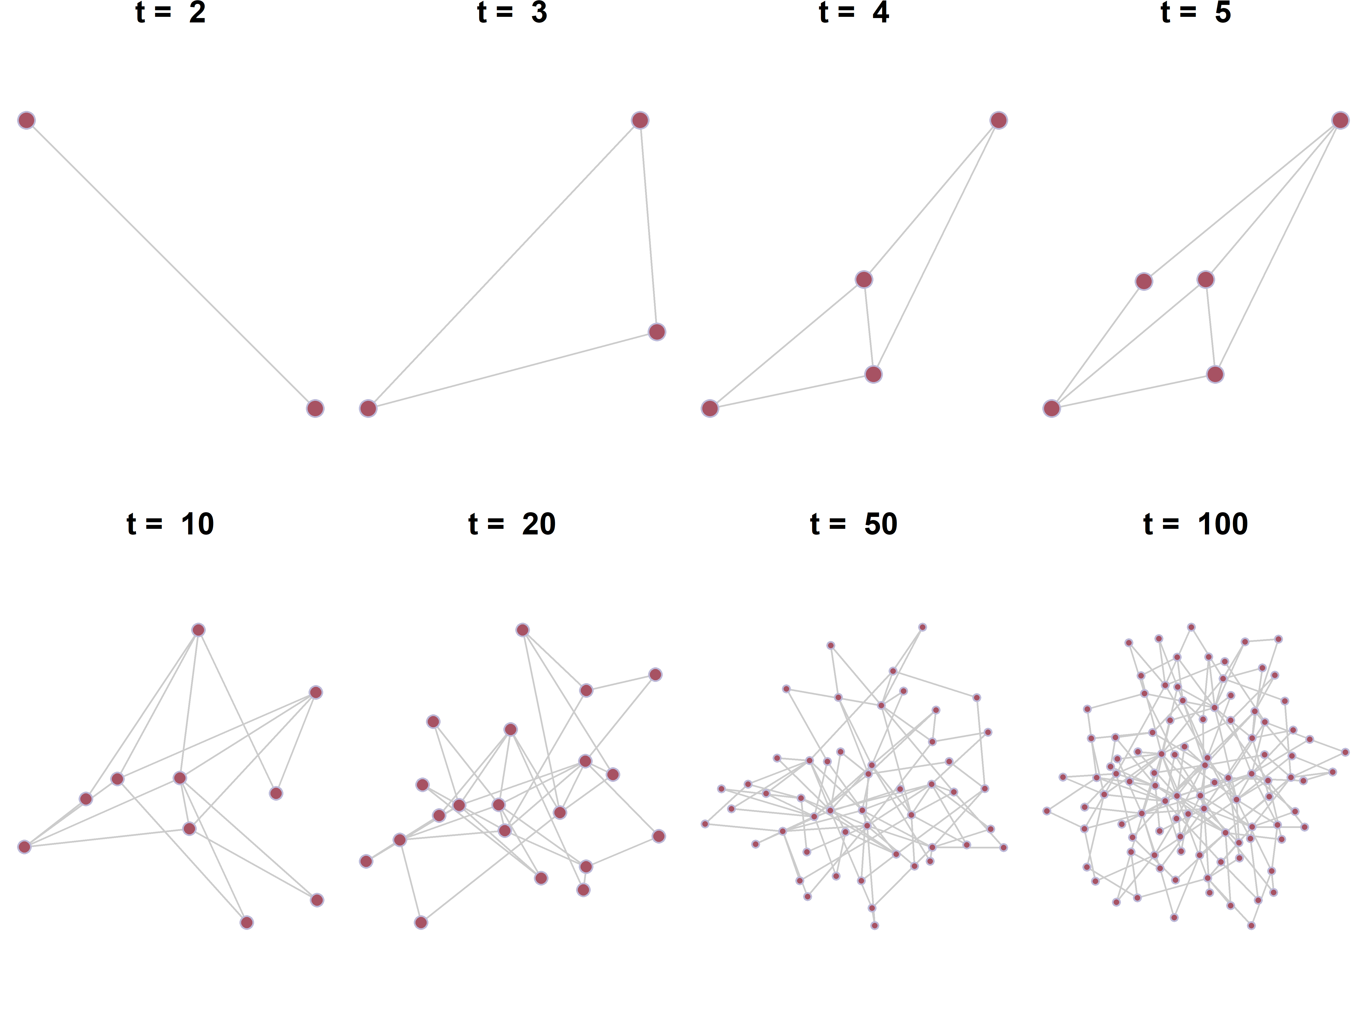

**Figure 1. Evolution of the Barabási-Albert Model.** The figure illustrates the dynamics of a growing network with 100 nodes, simulated over time. At each time step, a new node is added to the network, each with two links to existing nodes (*t* = 2, 3, 4, 5, 10, 20, 50, 100).

These two principles have been documented across diverse complex systems, including cellular networks, social structures, neural networks, and the Internet72. We propose that these same mechanisms characterize the formation of mental representations in social cognition. While the notion that conceptual knowledge in social cognition, such as how traits are associated, follows a network structure is not novel3,19,74,75, the specific structural characteristics and underlying generative processes remain unexplored. We argue that there are compelling computational grounds for the plausibility of growth and preferential attachment as organizing principles underlying social cognitive representations, particularly in domains such as trait inference.

The growth principle addresses a fundamental computational challenge: how finite human minds can develop increasingly complex social representations while maintaining cognitive tractability. This balance between complexity and manageability finds theoretical support in Piaget's theory of cognitive development. According to Piaget, individuals encountering new information can either assimilate it into existing cognitive structures or accommodate it by modifying those structures76. Despite beginning with rudimentary representations, these dual processes progressively accumulate complexity, enabling navigation in complex social environments. From an evolutionary perspective, this gradual development of mental representation confers computational advantages. If a representation is adaptive, such as correctly identity the trait of a potential mate or collaborator, then there is no reason to expect that all or most of this knowledge to be presented at birth or early childhood. Given the computational costs of maintaining complex mental representations, individuals typically develop them at later life stages when they become functionally necessary. This developmental trajectory aligns with the hierarchical structure of social interactions across the lifespan77,78. For example, self-protection precedes status seeking, which in turn precedes mate seeking. Thus, concepts related to mating can be acquired later than those related to social threat detection (e.g., warmth) without compromising effective navigation of age-appropriate social contexts.

This growth-based perspective diverges from early functional explanations of dimensional models that posit valence and dominance as fundamental dimensions because they help perceivers assess targets' intentions and capabilities8,54,79. Unlike these models, our framework does not assume fixed, fundamental representations of social cognition. It also differs from previous dimensional models that emphasized human cognitive limitations as justification for low-dimensional representations80. Instead, we propose that tractable organizational rules can govern environmental information processing while accommodating high-dimensional, complex representations that align with sophisticated social environments.

The second mechanism, preferential attachment, characterizes how new information like novel constructs are incorporated into established mental representations. Mathematically, preferential attachment is equivalent to a discrete-time stochastic process called the Chinese restaurant process (CRP) that has been widely used in nonparametric Bayesian models for explaining categorical cognition81,82. Recent applications of CRP to group formation and subgrouping in stereotype formation provide additional justification for its relevance to social cognition83. More intuitively, preferential attachment and CRP characterize a rich-get-richer pattern that nodes with higher degrees are more likely to absorb new concepts. In stereotype formation, this manifests as the tendency to categorize new individuals into more prevalent groups. In trait inference, this process may reflect perceivers' inclination to first consider connections between novel concepts (e.g., intelligence) and established, central concepts (e.g., attractiveness). Additional justification of preferential attachment comes from the more recent paradigm of cognitive modeling84. Resource rational analysis showed that the CRP-like mathematical form naturally emerges from a clustering process that seeks to minimize representational complexity85. When complexity is defined as the entropy of cluster assignment distributions, optimal use of limited cognitive resources favors assigning new items to existing clusters in proportion to their current size—precisely as predicted by CRP and preferential attachment. Therefore, preferential attachment represents a principled consequence of optimizing for low-entropy, capacity-efficient mental representations.

## **Mental Processing and the Interaction with Environmental Inputs**

Having established the structural principles underlying social cognitive representations, we now specify how processing operates within this architecture and responds to environmental input. One prominent idea in cognitive science is spreading activation, in which activation of one concept in semantic memory can be spread to and activate adjacent nodes in the network64. Several key characteristics define spreading activation dynamics. First, activation propagates recursively, enabling initially activated nodes to receive feedback from related nodes that subsequently become activated86. This recursive property creates dynamic patterns of mutual reinforcement within local network regions. Second, activation constitutes a limited cognitive resource that decays over time and distance87,88, or alternatively, exhibits a tendency to return to baseline resting levels3. Therefore, in a large network with long average path lengths, a few activations can be quickly vanished before propagating to the whole structure.

The processing dynamics operating on network structures are fundamentally shaped by environmental inputs and their interactions with network nodes. According to dynamic interactive theory of person perception3, certain nodes exhibit differential sensitivity to environmental activation. Specifically, trait evaluations related to valence demonstrate high sensitivity to visual and auditory cues that resemble expressive signals, enabling rapid automatic processing of social threat and safety information. In contrast, more abstract inferences such as personality assessments typically require detailed behavioral observations and sustained processing. The interaction between environmental inputs and spreading activation can be conceptualized as the initial endowment of activation to specific nodes, which subsequently propagate their activation to closely connected nodes through recursive spreading mechanisms.

## **Accessing the Feasibility of the Network Model**

While no empirical studies have directly evaluated the small-world topology of social cognitive networks, the feasibility of this network representation can be preliminarily assessed through neural, developmental, and cross-cultural evidence.

### ***Neural Feasibility and Constraints***

The proposed network model operates at Marr's algorithmic level of analysis, which is constrained by and builds upon the implementation level that specifies how representations are instantiated in neural circuits. Two primary possibilities exist for neural implementation. The first possibility involves localist representation, in which individual nodes (e.g., trait concept) map to a single neuron or a very small, dedicated group of neurons. Early studies on the neural network of the worm C. elegans have found a small-world structure89, with similar topology subsequently found in cats, macaque monkeys, and even humans90,91. These findings provided neural feasibility for a growing network model in social cognition. However, statistical analyses of semantic networks potentially related to social cognition suggest scale-free properties characterized by dramatic differences in node connectivity across orders of magnitude67. This scale-free architecture conflicts with neuroanatomical evidence indicating that neurons maintain relatively similar connection numbers92, raising questions about the direct neural implementation of such networks. The second possibility involves distributed representation; wherein individual nodes are represented through connectivity patterns between related neurons and their collective activation states. According to this view, as exemplified by recent high-dimensional models of social impressions19, trait impressions emerge as equilibrium states converged through thousands of neurons engaged in recurrent processing. Neuroimaging studies support this distributed perspective by demonstrating that the medial prefrontal cortex represents both warmth and competence dimensions93, suggesting that fundamental social cognitive dimensions can be instantiated by identical neural ensembles exhibiting different activation patterns. This distributed architecture may better accommodate the scale-free properties observed in semantic networks while remaining consistent with known neuroanatomical constraints.

### ***Developmental Support for Growing Network Models***

From a developmental perspective, both theoretical reasons and empirical evidence support the growing network model. Theoretically, as mentioned above, preferential attachment achieves cost-benefit efficiency across the lifespan by maintaining network sparsity through gradual construction. By gradually adding new nodes with relatively few connections over extended time scales, the network remains sparse, reducing the neural links and energy required for maintenance while preserving small-world topology that facilitates efficient activation propagation across the network. Empirically, the growing network model predicts that early-acquired nodes should exhibit higher degrees and centrality measures72. Two lines of research provide supporting evidence. First, age-of-acquisition ratings for over 30,000 English words demonstrate that words related to fundamental social dimensions are acquired early in development94. For instance, "nice" is estimated to be acquired at age 3.95, ranking 365th out of 31,124 words (top 1.17%). Similarly, trait terms such as "kind" (4.89 years), "pretty" (4.09 years), and "smart" (5.50 years) all demonstrate early acquisition and should therefore possess more connections within the network. Because these traits relate to readily accessible perceptual cues7,8, they can rapidly distribute activation to other nodes, inducing the high covariance patterns observed in dimensional models. Second, research on facial attributions reveals robust child-adult agreement in judgments of fundamental social dimensions95,96. These findings support the growing network model by demonstrating that network structures underlying these core evaluations are established early in development. Additionally, developmental changes in consensus patterns provide further network-based insights. Specifically, consensus on warmth judgments based on faces varying in warmth (within-concept judgment) increases with age, while adults show reduced consensus when evaluating faces varying in competence as "mean" or "nice" (between-concept judgment)95. This pattern suggests that children's networks for concepts like "warmth" may contain only a subset of all warmth-related nodes due to their developmental stage, resulting in lower between-child consensus. However, because children's networks are less differentiated, activation from warmth-related nodes can easily propagate to competence-related nodes rather than circulating among different warmth-specific nodes, producing the seemingly counterintuitive developmental patterns observed in this research.

### ***Cross-Cultural Variability and Network Representations***

Cross-cultural studies lend additional credits to the growing network model. When investigating the generalizability of the Big Two model of face perception, a large-scale study spanning 41 countries reported inconsistent results, with some regions found more than two factors97. This variability suggests that universal dimensional models may inadequately capture the complexity of social cognitive representations across different cultural contexts98. Moreover, a recent study20 applying network analysis found considerate differences in connectivity patterns between traits, social categories, and mental states across regions. Therefore, a low-dimensional factor model could obscure important details in mental representation of social cognition. The regional difference implies that individual nodes like trait judgments are associated differently depending on sociocultural context, which may be better captured through fine-grained network representation that can accommodate cultural specificity.

# **Small-World Properties Induce Low-Dimensional Psychology Under Constrained Stimuli**

Having elaborated the network structure, processing dynamics, and their interactions, we now advance our central argument: previously observed low-dimensional psychology can be understood as an emergent phenomenon when environmental input is constrained. To develop this argument, we first provide formal analysis of the network model, deriving relationships between node distances (e.g., trait similarities in person perception) and their correlations. While we present intuitive and accessible demonstrations in the main text, more rigorous mathematical derivations are available in supplementary materials. Following this statistical analysis, we connect these properties to established findings in social cognition.

Networks generated through growth and preferential attachment mechanisms exhibit ultra-small world characteristics99. Although randomly connected networks can display small-world properties, scale-free networks demonstrate even more compressed connectivity. Specifically, the average distance between nodes scales with *ln(ln N)* rather than the typical *lnN* observed in random networks, where *N* represents network size. This ultra-small behavior emerges from the presence of hubs—nodes with exceptionally high connectivity that can link distant network regions in remarkably few steps (Figure 2). Therefore, seemingly unrelated nodes can rapidly expand their reachable activation space through hub-mediated pathways, enabling distant concepts to achieve comparable activation levels despite their conceptual separation.

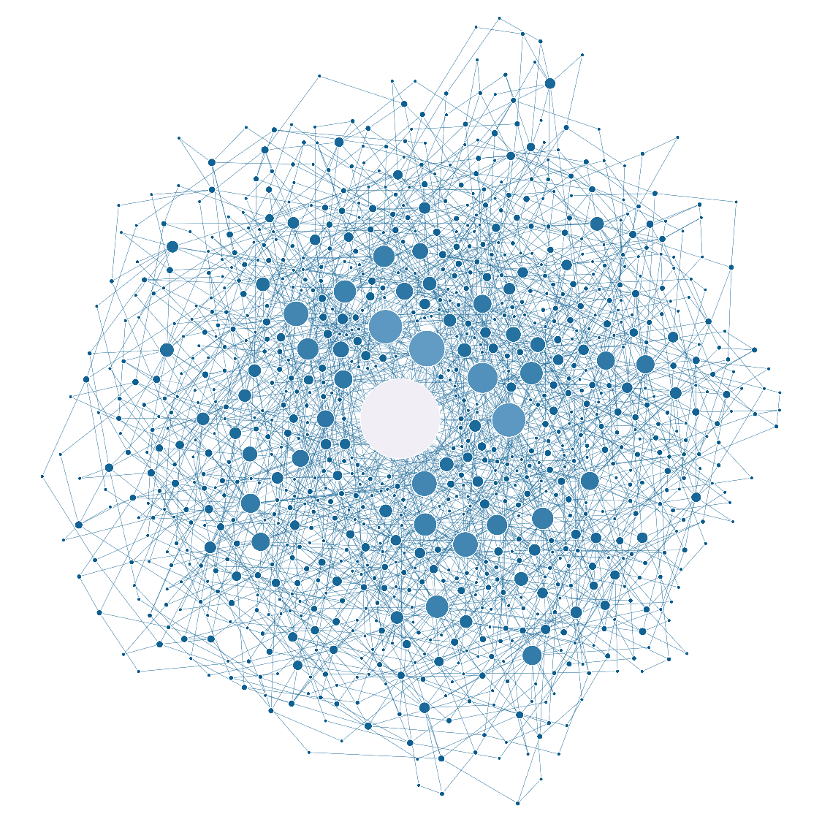

**Figure 2. A Large-Scale Growing Network.** This figure depicts a growing network of 1000 nodes. At each time step, a new node, linked to two existing nodes, is added to the network. The size and color of each node are proportional to its degree (i.e., the number of links), with larger nodes and lighter colors indicating higher degrees. The largest grey node represents the network hub, which connects multiple isolated nodes.

To build intuition about how closely connected nodes are within a growing network, we can derive the expected number of links between two nodes with degree and by a distance of *d* (e.g., with *d*-1​ intermediate nodes). The derivation is based on the configuration model in complex network theory100,101, which is a commonly used starting point for analyzing a complex network. At a basic level, the expected number of links of the two nodes is proportional to the product of their degrees: the higher their degrees, the greater the likelihood of a direct connection. This principle extends to longer distances, where the probability of connection remains proportional to the degrees but is amplified exponentially by a factor dependent on the network’s degree distribution. As a result, even nodes with moderate degrees can have more than one expected indirect path between them, making them likely to be only two steps apart (Figure 3). In real-world network, the expected number of links is further amplified due to assortative mixing102, where high-degree nodes tend to connect preferentially with other high-degree nodes.

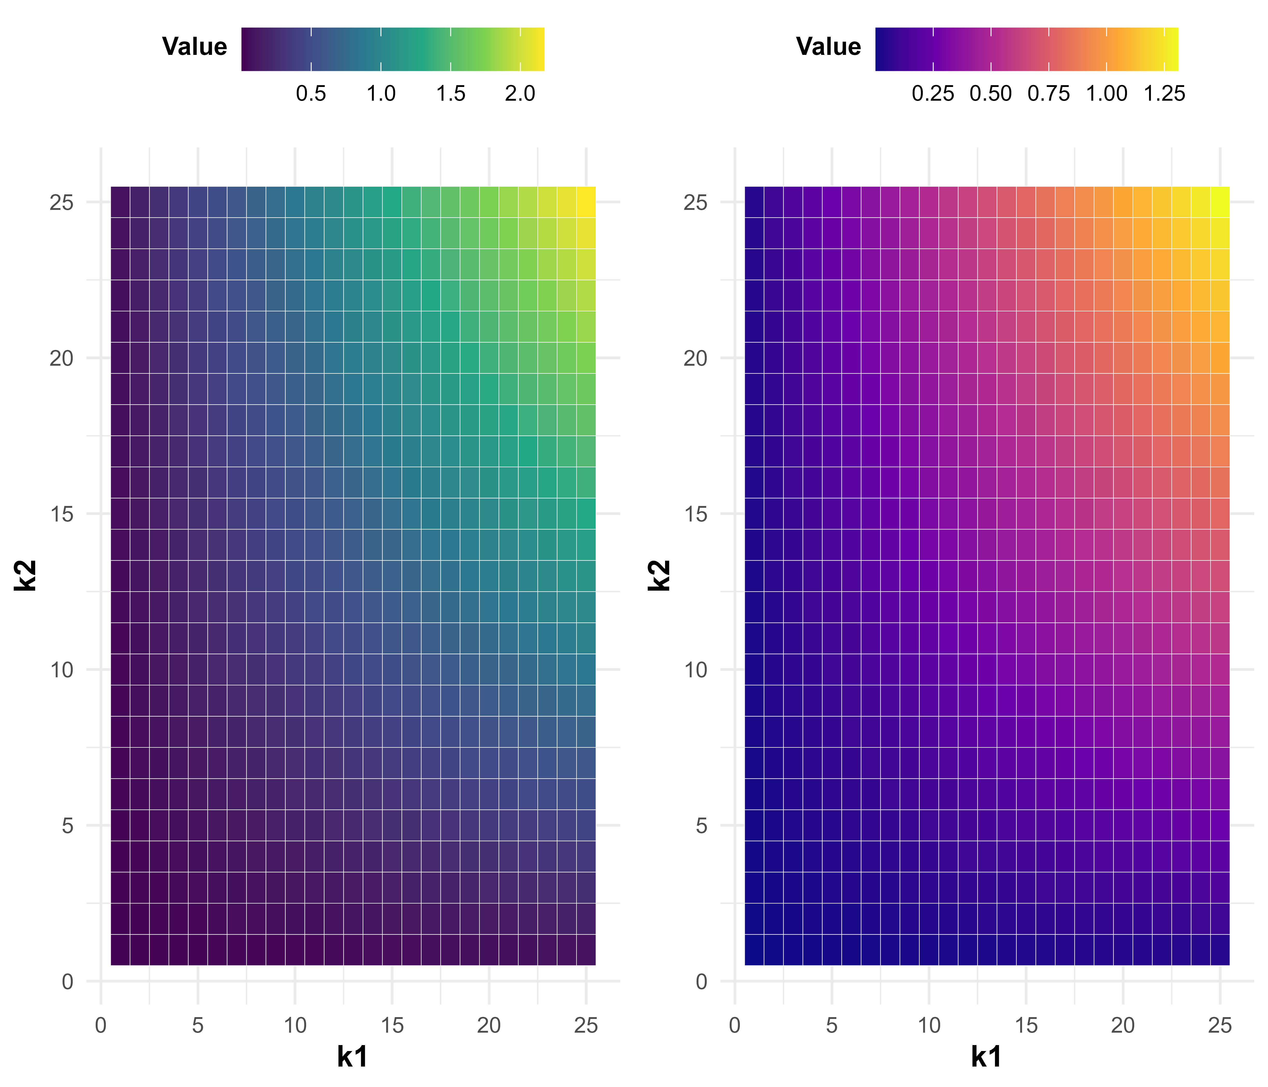

**Figure 3. Expected Links Between Two Nodes of Given Degrees.** The density maps display the expected number of links between two nodes with degrees k1​ and k2​, calculated based on their degrees and the total number of edges in the network. The left panel is based on a growing network of 500 nodes with 3 links added at each time step; the right panel is based on a network of 200 nodes with 2 links added per step. Warmer colors indicate higher expected connectivity. As predicted by the model, nodes with higher degrees are more likely to be connected.

Assuming that activation spreads through a network with some random noise at each step3, the correlation between the activation levels of two nodes becomes a function of their distance—shorter distances produce stronger correlations. In a weighted network, where each edge has an associated strength, the degree of correlation is further influenced by these edge weights. In psychological networks, such as those representing traits or stereotypes, these weights may be relatively high, leading to strong correlations in activation due to limited distinctiveness between nodes. Unlike social networks, where nodes clearly represent distinct individuals or entities, psychological constructs (e.g., attractiveness) are often defined at a coarser level of granularity103. As a result, neighboring constructs may share substantial variance, further enhancing their correlations within the network.

## **Reinterpret the Beauty-is-Good Effect**

These analyses offer an alternative explanation for both the beauty-is-good effect and the emergence of psychological dimensions (Figure 4). From a network perspective, the beauty-is-good effect can be seen as an emergent property of activation patterns when only limited cues such as facial or short verbal descriptions are available. Consider the commonly reported correlation between attractiveness and perceived intelligence17,42. If these two constructs are closely connected in a large-scale network, their short distance would explain the strong correlation in activation. Attractiveness or related inference like “pretty” likely holds a central position in the person perception network due to its early acquisition and high accessibility, giving it a “first-mover” advantage. Intelligence, shaped by cultural norms and folk theories, is broadly connected to various traits, contributing to its high degree. When constrained stimuli like faces without auditory and social interactions are presented, the activation in the network is sparse and concentrated on accessible nodes like attractiveness. The activation of attractiveness is then quickly passed to intelligence without significant decay due to the short distance, creating the appearance of direct association. In such constrained experimental settings when multisensory social cues and interactions are missing, abstract traits (e.g., intelligence or morality) receive little direct activation from the environment and thus rely heavily on proximal, frequently activated nodes.

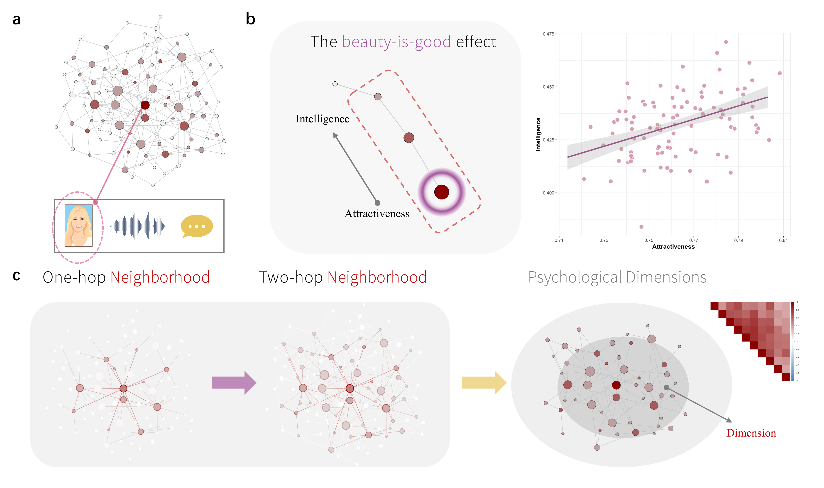

**Figure 4. A Network Perspective on the Beauty-is-Good Effect and Psychological Dimensions.** This figure presents a reinterpretation of the attractiveness halo effect and psychological dimensions from a network perspective. (a) In typical studies, constrained stimuli, such as isolated face images, are used to elicit social attributions. (b) The node representing attractiveness can be easily activated by environmental inputs, and its activation is rapidly transmitted to neighboring nodes, such as “intelligence.” This activation decays with distance but, due to the small-world property of the network, can quickly reach seemingly unrelated nodes like “intelligence,” producing proportional activation. Our simulation revealed a strong correlation (*r* = 0.50, *p* < .001) between the initially activated node (e.g., attractiveness) and a two-hop neighbor (e.g., intelligence). (c) The initial activation spreads to one-hop neighbors (directly connected nodes), then to two-hop neighbors (nodes that are indirectly connected through one intermediate node), resulting in similar activation patterns across the network. These similar activation patterns lead to high shared covariance, which creates the appearance of latent psychological dimensions.

A key prediction of the network model is that the *beauty-is-good* effect should weaken or even disappear when richer social information is available and when initial activations conflict. Our simulations, which introduced diverse environmental inputs to the network, support this prediction (Figure 5). Empirical findings are consistent with this view. For instance, when naturalistic images that include context such as body posture, movement, clothing, and situational cues are used, the correlation between attractiveness and perceived warmth drops to 0.1260. In contrast, earlier studies relying on static face images reported much stronger effects. For example, a recent study found a correlation of 0.41104. Similarly, while face-based studies often find a strong link between attractiveness and perceived intelligence (*r* = 0.81)42, this association becomes statistically insignificant and approaches zero (*r* = -0.04) when social inferences are based on dynamic video clips20.

图表

AI 生成的内容可能不正确。

**Figure 5. Weaker Correlations Between Social Attributions Under Naturalistic Stimuli.** (a) When a single constrained stimulus is used, and only one or a few nodes are activated, the activations of different nodes quickly reach equilibrium and become similar. Each line represents the activation of a single node across time points. (b) When multiple constrained stimuli are presented, the correlation between activations across stimuli can be calculated, as done in prior studies. The correlation matrix indicates strong overall correlations between activations. In our simulation, a single latent factor accounted for 60% of the variance, consistent with previous findings. (c) When high-dimensional environmental input (e.g., multisensory social information) is provided, activations between nodes become less similar and more unstable. As a result, the correlations between activations weaken, with a single latent factor accounting for only 12% of the variance, in line with some prior studies.

## **Reinterpret Psychological Dimensions**

A similar logic applies to findings on psychological dimensions. Early studies often paired face images with a limited set of pre-selected traits, raising concerns that the identified dimensions may reflect inadequate stimuli sampling50,105,106. Indeed, many studies relied on a priori theories, such as the warmth-competence framework, selecting traits accordingly. This approach introduces semantic redundancy and inflates inter-trait correlations. Even with more systematic sampling of both face stimuli and trait descriptors, a low-dimensional structure often emerges12,50, unless the stimuli include richer social information such as auditory or verbal content20. This suggests that the richness of social input plays a critical role in revealing the true structure of mental representations in social cognition.

The statistical prerequisite for dimensions to emerge is the high shared variance among measures107,108. This can be evaluated using the Measure of Sampling Adequacy (MSA), which ranges from 0 to 1 and estimates whether a given trait shares sufficient variance with others to justify latent factors109. A low MSA value indicates that a trait has unique associations not easily reducible to shared dimensions. If we view trait representations as a network, then MSA values become highly dependent on the nature of the input. When constrained stimuli like face images are used, only a few nodes are activated. These activations then spread in parallel, creating uniform influence across neighboring nodes, mimicking the statistical effect of a latent dimension. Thus, high shared variance under constrained input may not reflect genuine dimensionality, but rather an artifact of limited activation in a high-dimensional network.

This reasoning also clarifies why the most commonly identified dimensions correspond to readily accessible visual cues. For instance, the prevalent warmth dimension is closely linked to facial expression features8, while attractiveness in the 3-D models7 and youthfulness in the 4-D model12 similarly rely on visual salience. This mechanism mirrors Asch’s classic findings on impression formation, where a small change in a central trait word (e.g., "warm" vs. "cold") significantly altered participants’ overall impressions44. Such results align more naturally with a network perspective, where a few highly connected nodes influence the broader activation pattern, rather than with a strict dimensional model62. When the stimuli are naturalistic and diverse, the conditional independence assumption of latent factors can be violated. This assumption holds that, once the latent factors are accounted for, individual traits should no longer be directly related110–112. In naturalistic settings, although nodes associated with visual input can still serve important anchors, other nodes can access auditory, semantic, and behavior information and thus have their unique variance. Suppose a positive association between node activation and behavioral measures, this pattern largely decreases common variance between nodes and thus correlations between behavioral measures like trait ratings. As a result, when analyzing data under these more naturalistic settings, a low-dimensional space cannot explain the variance between measures. Instead, one may detect communities in the network113, which are clusters of nodes (traits) grouped by connectivity rather than shared variance (Figure 6). Studies of both personality and person perception have revealed such communities, which often resemble traditional dimensions20,62,114. This suggests that psychological dimensions may emerge from the network structure of mental representations, rather than reflect fixed latent constructs.

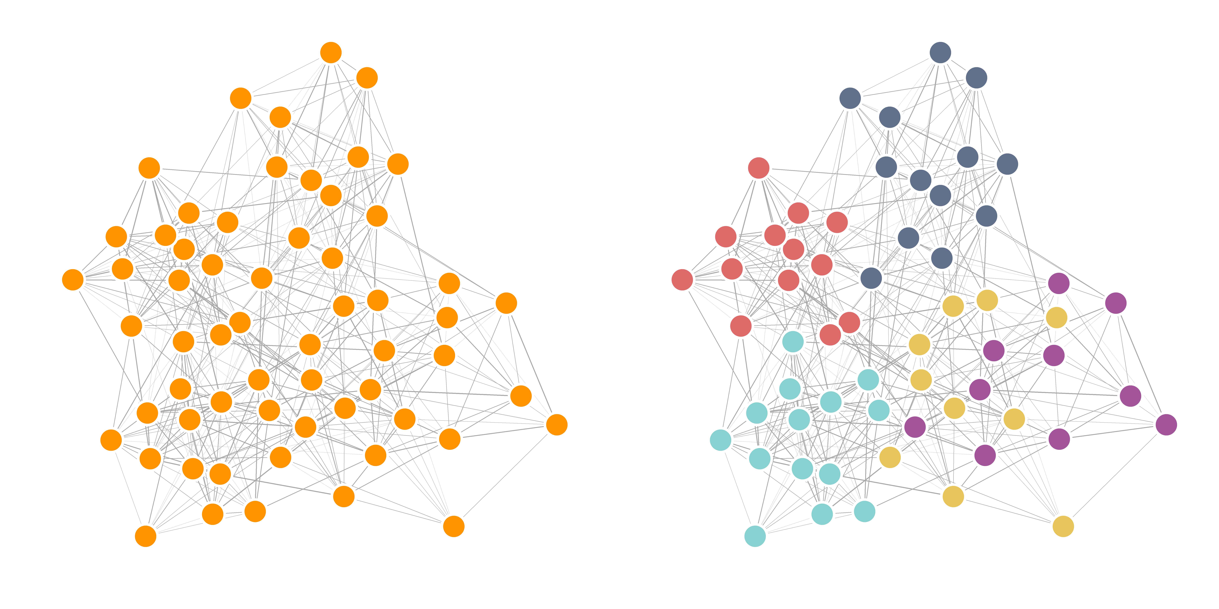

**Figure 6. Communities as an Alternative Perspective of Psychological Dimensions.** NetworkS without (left) and with (right) communities annotated are illustrated. Densely connected regions within a network, known as communities, can be identified using community detection algorithms that focus on network structure rather than the covariance of activations between nodes113,115–117. These densely connected regions (annotated in different colors) may serve as structural prerequisites for psychological dimensions when constrained stimuli are applied. When a node within a community is activated, the activation can spread to other nodes within the same community, rapidly leading to similar activation patterns and high correlations between measures.

# **Moving Beyond Low-Dimensional Paradigms in Social Cognition**

Social cognition research has been dominated by methodologically constrained stimuli that limits the complexity and ecological validity of social information. These approaches, while offering precise methodological control, may fundamentally distort our understanding of how people mentally represent and process social information by creating unreasonably high correlation between measures and thus a low-dimensional projection of human psychology.

Recent studies have identified persistent concerns about inadequate stimulus sampling in social cognition research20,50,53,60,105,106,118,119. The field's overwhelming focus on white faces represents the most glaring limitation. While some meaningful strides have been made to diversify face stimuli12, they still operate within a constrained framework—adding diversity along a single dimension (e.g., face) rather than increasing the dimensionality of available information. Similarly, emotion recognition research has been dominated by prototypical facial expressions representing extreme forms of core emotions, potentially overlooking the subtle, context-dependent expressions that characterize real-world interactions120. This limitation becomes particularly apparent when considering how people attend to social information in naturalistic settings. Recent studies showed that only 14% of eye gaze patterns are directed toward faces in realistic settings when additional social information is available121. In contrast, social interaction in naturalistic contexts involves multiple streams of information, including visual cues from actions and behaviors, auditory information, and contextual information. These information streams are sometimes deemed more reliable by participants and thus cannot be neglected in experimental designs122. For example, emotion inferences made by participants were well captured by contextual information alone while isolated facial cues are insufficient123. Additionally, relational visual information characterizing how individuals interact has been identified as an important cue that humans rely on when making social inferences124.

The persistence of low-dimensional paradigms in social cognition research may reflect deeper cognitive and cultural biases toward simplicity. Humans possess strong motivations to understand and find meaning in their experiences125, and given the inherent complexity of human psychology, this motivation compels researchers to create mental placeholders that establish feelings of certainty and understanding126. Beyond these innate tendencies, cultural norms in social science favor verbal descriptions over mathematical representations when communicating research findings (Watts, 2017). This preference may inadvertently promote low-dimensional accounts of psychology because they are easier to communicate, remember, and reproduce during social transmission127. Empirical evidence supports this thypothesis. Studies examining stereotype formation found that while participants initially represented artificially created aliens using a relatively high-dimensional trait space, these stereotypes gradually degraded to low-dimensional representations after transmitting through several generations of participants128. Similar processes may operate in scientific production and transmission, suggesting that our innate cognitive tendencies systematically distort the dimensionality of psychological science, favoring simplified models that are more readily communicated but potentially less accurate in modeling psychological reality.

To advance our understanding of social cognition in naturalistic settings, it is necessary to move beyond both low-dimensional paradigms and the simplifying mindset that underlies them127. We argue that progress requires two complementary approaches: incorporating the complexity of real-world social interactions into experimental designs and developing quantitative mental models that make precise predictions about behavior. First, experiments should be reconceptualized as simplified models of real-world situations rather than isolated manipulations of single variables129. Since social cognition processes like impression formation typically extend beyond single time slices or glimpses of faces, experiments should incorporate essential components such as multisensory information and dynamic social interactions. However, simply manipulating multiple cues may not be sufficient, as the way cues are integrated and combined can largely influence behavioral outcomes59,123,130. This complexity necessitates the development of explicit mental representation models that clearly specify how cues are processed and transformed into the behavioral measures observed in experiments. In our research, for example, we model mental representations as complex networks following growth and preferential attachment principles, with behavioral measures derived from patterns of node activations within these networks. This approach exemplifies a broader methodological philosophy: mental models should function as systematic procedures that convert raw perceptual input into specific behavioral outputs through well-defined mathematical transformations. Just as a recipe describes how to optimally combine ingredients to produce a finished dish, a psychological model represents a general mathematical function that transforms environmental inputs into behavioral responses127,131. Both recipes and mental models serve as systematic procedures that reliably convert raw materials, whether ingredients or sensory data, into desired outcomes through explicit, reproducible processes.

# **Conclusions**

In this perspective, we reviewed two longstanding lines of research in social cognition and provided an alternative explanation grounded in complex network perspective. Drawing on studies from the past 50 years, we framed both the beauty-is-good halo effect and dimensional models across various domains of social cognition as manifestations of a low-dimensional perspective, as both lines of studies featuring high correlations between individual measures. Inspired by more recent advances in high-dimensional social cognition, we proposed that prior low-dimensional findings may emerge from a growing network structure operating under constrained stimuli. Mechanistically, the growing network possesses a small-world topology which shortens the distance between seemingly unrelated nodes and results in strong correlations between node activation and behavioral responses. Although the perspective is exploratory, it provides fruitful predictions and directions for future studies on social cognition. We advocate moving beyond low-dimensional thinking and paradigms to achieve a more ecologically valid understanding of how people perceive and organize social traits and behaviors.

# **References**

1. Amodio, D. M. A learning and memory account of impression formation and updating. *Nat Rev Psychol* (2025) doi:10.1038/s44159-025-00445-x.

2. Uleman, J. S., Adil Saribay, S. & Gonzalez, C. M. Spontaneous Inferences, Implicit Impressions, and Implicit Theories. *Annu. Rev. Psychol.* **59**, 329–360 (2008).

3. Freeman, J. B. & Ambady, N. A dynamic interactive theory of person construal. *Psychological Review* **118**, 247–279 (2011).

4. Fiske, S. T., Cuddy, A. J. C., Glick, P. & Xu, J. A model of (often mixed) stereotype content: Competence and warmth respectively follow from perceived status and competition. *Journal of Personality and Social Psychology* **82**, 878–902 (2002).

5. Marr, D. *Vision: A Computational Investigation into the Human Representation and Processing of Visual Information*. (MIT press, 1982).

6. Goldberg, L. R. An alternative ‘description of personality’: the big-five factor structure. *J Pers Soc Psychol* **59**, 1216–1229 (1990).

7. Sutherland, C. A. M. *et al.* Social inferences from faces: Ambient images generate a three-dimensional model. *Cognition* **127**, 105–118 (2013).

8. Oosterhof, N. N. & Todorov, A. The functional basis of face evaluation. *Proc. Natl. Acad. Sci. U.S.A.* **105**, 11087–11092 (2008).

9. Ekman, P. & Friesen, W. V. Constants across cultures in the face and emotion. *Journal of Personality and Social Psychology* **17**, 124–9 (1971).

10. Thornton, M. A. & Tamir, D. I. People represent mental states in terms of rationality, social impact, and valence: Validating the 3d Mind Model. *Cortex* **125**, 44–59 (2020).

11. Rosenberg, S., Nelson, C. & Vivekananthan, P. S. A multidimensional approach to the structure of personality impressions. *Journal of Personality and Social Psychology* **9**, 283–294 (1968).

12. Lin, C., Keles, U. & Adolphs, R. Four dimensions characterize attributions from faces using a representative set of English trait words. *Nat Commun* **12**, 5168 (2021).

13. Dion, K. & Walster, E. WHAT IS BEAUTIFUL IS GOOD. *Journal of Personality and Social Psychology* **24**, 285–290 (1972).

14. Eagjy, A. H., Ashmore, R. D. & Makhijani, M. G. What Is Beautiful Is Good, But. . .: A Meta-Anatytic Review of Research on the Physical Attractiveness Stereotype. *Psychological Bulletin* **110**, 109–128 (1991).

15. Feingold, A. Understanding the physical attractiveness literature: Qualitative reviews versus meta-analysis. *Behavioral and Brain Sciences* **40**, e28 (2017).

16. Feingold, A. Good-looking people are not what we think. *Psychological Bulletin* **111**, 304–341 (1992).

17. Zebrowitz, L. A., Hall, J. A., Murphy, N. A. & Rhodes, G. Looking Smart and Looking Good: Facial Cues to Intelligence and their Origins. *Pers Soc Psychol Bull* **28**, 238–249 (2002).

18. Han, Y. & Adolphs, R. A shared structure for emotion experiences from narratives, videos, and everyday life. *iScience* **27**, (2024).

19. Freeman, J. B. & Lin, C. A high-dimensional model of social impressions. *Trends in Cognitive Sciences* S136466132500110X (2025) doi:10.1016/j.tics.2025.04.011.

20. Lu, J. & Lin, C. Network models reveal high-dimensional social inferences in naturalistic settings beyond latent construct models. *Commun Psychol* **3**, (2025).

21. Freeman, J. B., Stolier, R. M. & Brooks, J. A. Dynamic interactive theory as a domain-general account of social perception. in *Advances in Experimental Social Psychology* vol. 61 237–287 (Elsevier, 2020).

22. Brooks, J. A. *et al.* Deep learning reveals what facial expressions mean to people in different cultures. *iScience* **27**, 109175 (2024).

23. Cowen, A. S. *et al.* How emotion is experienced and expressed in multiple cultures: a large-scale experiment across North America, Europe, and Japan. *Front. Psychol.* **15**, 1350631 (2024).

24. Cowen, A. S., Fang, X., Sauter, D. & Keltner, D. What music makes us feel: At least 13 dimensions organize subjective experiences associated with music across different cultures. *Proc. Natl. Acad. Sci. U.S.A.* **117**, 1924–1934 (2020).

25. Cowen, A. S. & Keltner, D. Self-report captures 27 distinct categories of emotion bridged by continuous gradients. *Proc. Natl. Acad. Sci. U.S.A.* **114**, (2017).

26. Cowen, A. S. *et al.* Facial movements have over twenty dimensions of perceived meaning that are only partially captured with traditional methods. Preprint at https://doi.org/10.31234/osf.io/hc93t (2021).

27. Connor, P., Nicolas, G., Antonoplis, S. & Koch, A. Unconstrained Descriptions of Facebook Profile Pictures Support High-Dimensional Models of Impression Formation. *Personality and Social Psychology Bulletin* **0**, 1–17 (2024).

28. Nicolas, G., Uddenberg, S. & Todorov, A. Spontaneous Content of Impressions of Naturalistic Face Photographs. *Social Cognition* **43**, 114–143 (2025).

29. Nicolas, G., Bai, X. & Fiske, S. T. A spontaneous stereotype content model: Taxonomy, properties, and prediction. *Journal of Personality and Social Psychology* **123**, 1243–1263 (2022).

30. Jackson, L. A., Hunter, J. E. & Hodge, C. N. Physical Attractiveness and Intellectual Competence: A Meta-Analytic Review. *Social Psychology Quarterly* **58**, 108–122 (1995).

31. Langlois, J. H. *et al.* Maxims or myths of beauty? A meta-analytic and theoretical review. *Psychological Bulletin* **126**, 390–423 (2000).

32. Kanazawa, S. Intelligence and physical attractiveness. *Intelligence* **39**, 7–14 (2011).

33. Sheehan, C. M. & Hamermesh, D. S. Looks and longevity: Do prettier people live longer? *Social Science & Medicine* **354**, 117076 (2024).

34. Kanazawa, S. Why beautiful people are more intelligent. *Intelligence* **32**, 227–243 (2004).

35. Zebrowitz, L. A., Fellous, J.-M., Mignault, A. & Andreoletti, C. Trait Impressions as Overgeneralized Responses to Adaptively Significant Facial Qualities: Evidence from Connectionist Modeling. *Pers Soc Psychol Rev* **7**, 194–215 (2003).

36. De Jager, S., Coetzee, N. & Coetzee, V. Facial Adiposity, Attractiveness, and Health: A Review. *Front. Psychol.* **9**, 2562 (2018).

37. Weeden, J. & Sabini, J. Physical Attractiveness and Health in Western Societies: A Review. *Psychological Bulletin* **131**, 635–653 (2005).

38. Thornhill, R. & Gangestad, S. W. Human facial beauty: Averageness, symmetry, and parasite resistance. *Human Nature* **4**, 237–269 (1993).

39. Zebrowitz, L. A. & Rhodes, G. Sensitivity to “Bad Genes” and the Anomalous Face Overgeneralization Effect: Cue Validity, Cue Utilization, and Accuracy in Judging Intelligence and Health. *Journal of Nonverbal Behavior* **28**, 167–185 (2004).

40. Zebrowitz, L. A. First Impressions From Faces. *Curr Dir Psychol Sci* **26**, 237–242 (2017).

41. Gulati, A. *et al.* What is beautiful is still good: the attractiveness halo effect in the era of beauty filters. *R. Soc. Open Sci.* **11**, 240882 (2024).

42. Talamas, S. N., Mavor, K. I. & Perrett, D. I. Blinded by Beauty: Attractiveness Bias and Accurate Perceptions of Academic Performance. *PLOS ONE* **11**, e0148284 (2016).

43. Mitchem, D. G. *et al.* No relationship between intelligence and facial attractiveness in a large, genetically informative sample. *Evolution and Human Behavior* **36**, 240–247 (2015).

44. Asch, S. E. Forming impressions of personality. *The journal of abnormal and social psychology* **41**, 258 (1946).

45. Wishner, J. Reanalysis of ‘impressions of personality.’ *Psychological Review* **67**, 96–112 (1960).

46. Liebenow, H. A., Boucher, K. L. & Cassidy, B. S. Trait inferences from the “big two” produce gendered expectations of facial features. *Journal of Experimental Social Psychology* **111**, 104585 (2024).

47. Martin, A. E. & Slepian, M. L. The Primacy of Gender: Gendered Cognition Underlies the Big Two Dimensions of Social Cognition. *Perspect Psychol Sci* **16**, 1143–1158 (2021).

48. Abele, A. E. & Wojciszke, B. Agency and communion from the perspective of self versus others. *Journal of Personality and Social Psychology* **93**, 751–763 (2007).

49. Abele, A. E. & Bruckmüller, S. The bigger one of the “Big Two”? Preferential processing of communal information. *Journal of Experimental Social Psychology* **47**, 935–948 (2011).

50. Jones, A. L., Shiramizu, V. & Jones, B. C. Decoding the language of first impressions: Comparing models of first impressions of faces derived from free‐text descriptions and trait ratings. *British J of Psychology* bjop.12717 (2024) doi:10.1111/bjop.12717.

51. Brambilla, M., Rusconi, P., Sacchi, S. & Cherubini, P. Looking for honesty: The primary role of morality (vs. sociability and competence) in information gathering. *Eur. J. Soc. Psychol.* **41**, 135–143 (2011).

52. Brambilla, M., Sacchi, S., Rusconi, P. & Goodwin, G. P. The primacy of morality in impression development: Theory, research, and future directions. in *Advances in Experimental Social Psychology* vol. 64 187–262 (Elsevier, 2021).

53. Sutherland, C. A. M. & Young, A. W. Understanding trait impressions from faces. *British J of Psychology* **113**, 1056–1078 (2022).

54. Fiske, S. T., Cuddy, A. J. C. & Glick, P. Universal dimensions of social cognition: warmth and competence. *Trends in Cognitive Sciences* **11**, 77–83 (2007).

55. Zebrowitz, L. A. & Montepare, J. M. Social Psychological Face Perception: Why Appearance Matters. *Social and Personality Psychology Compass* **2**, 1497–1517 (2008).

56. Olivola, C. Y. & Todorov, A. Fooled by first impressions? Reexamining the diagnostic value of appearance-based inferences. *Journal of Experimental Social Psychology* **46**, 315–324 (2010).

57. Kahneman, D. A perspective on judgment and choice: Mapping bounded rationality. *American Psychologist* **58**, 697–720 (2003).

58. Stamkou, E., Keltner, D., Corona, R., Aksoy, E. & Cowen, A. S. Emotional palette: a computational mapping of aesthetic experiences evoked by visual art. *Sci Rep* **14**, 19932 (2024).

59. Zaki, J. Cue Integration: A Common Framework for Social Cognition and Physical Perception. *Perspect Psychol Sci* **8**, 296–312 (2013).

60. Zheng, R. & Lin, C. Cues driving trait impressions in naturalistic contexts are sparse. *Preprint at Https://Doi. Org/10.31234/Osf. Io/V39tk* (2024).

61. Epskamp, S., Borsboom, D. & Fried, E. I. Estimating psychological networks and their accuracy: A tutorial paper. *Behav Res* **50**, 195–212 (2018).

62. Cramer, A. O. J. *et al.* Dimensions of Normal Personality as Networks in Search of Equilibrium: You Can’t like Parties if you Don’t like People. *Eur J Pers* **26**, 414–431 (2012).

63. Siew, C. S. Q., Wulff, D. U., Beckage, N. M., Kenett, Y. N. & Meštrović, A. Cognitive Network Science: A Review of Research on Cognition through the Lens of Network Representations, Processes, and Dynamics. *Complexity* **2019**, 1–24 (2019).

64. Collins, A. M. & Loftus, E. F. A spreading-activation theory of semantic processing. *Psychological review* **82**, 407 (1975).

65. Collins, A. M. & Quillian, M. R. Retrieval time from semantic memory. *Journal of verbal learning and verbal behavior* **8**, 240–247 (1969).

66. Kemp, C., Perfors, A. & Tenenbaum, J. B. Learning overhypotheses with hierarchical Bayesian models. *Developmental Science* **10**, 307–321 (2007).

67. Steyvers, M. & Tenenbaum, J. B. The Large‐Scale Structure of Semantic Networks: Statistical Analyses and a Model of Semantic Growth. *Cognitive Science* **29**, 41–78 (2005).

68. de Sola Pool, I. & Kochen, M. Contacts and influence. *Social networks* **1**, 5–51 (1978).

69. Milgram, S. The small world problem. *Psychology today* **2**, 60–67 (1967).

70. On the evolution of random graphs. *The Structure and Dynamics of Networks* **17**, 38–82 (1960).

71. Barabasi, A.-L. & Albert, R. Emergence of Scaling in Random Networks. *Science* **286**, 509–512 (1999).

72. Barabási, A.-L. Scale-Free Networks: A Decade and Beyond. *Science* **325**, 412–413 (2009).

73. Newman, M. *Networks*. (Oxford university press, 2018).

74. Stolier, R. M., Hehman, E. & Freeman, J. B. Trait knowledge forms a common structure across social cognition. *Nat Hum Behav* **4**, 361–371 (2020).

75. Stolier, R. M., Hehman, E. & Freeman, J. B. A Dynamic Structure of Social Trait Space. *Trends in Cognitive Sciences* **22**, 197–200 (2018).

76. Piaget, J. *The Construction of Reality in the Child*. (Routledge, 2013).

77. Neel, R., Kenrick, D. T., White, A. E. & Neuberg, S. L. Individual differences in fundamental social motives. *Journal of Personality and Social Psychology* **110**, 887–907 (2016).

78. Kenrick, D. T., Griskevicius, V., Neuberg, S. L. & Schaller, M. Renovating the Pyramid of Needs: Contemporary Extensions Built Upon Ancient Foundations. *Perspectives on Psychological Science* **5**, 292–314 (2010).

79. Todorov, A., Said, C. P., Engell, A. D. & Oosterhof, N. N. Understanding evaluation of faces on social dimensions. *Trends in Cognitive Sciences* **12**, 455–460 (2008).

80. Olivola, C. Y. & Todorov, A. Elected in 100 milliseconds: Appearance-Based Trait Inferences and Voting. *J Nonverbal Behav* 28 (2010).

81. Aldous, D. J. Exchangeability and related topics. in *Lecture Notes in Mathematics* 1–198 (Springer Berlin Heidelberg, Berlin, Heidelberg, 1985). doi:10.1007/bfb0099421.

82. Gershman, S. J. & Blei, D. M. A tutorial on Bayesian nonparametric models. *Journal of Mathematical Psychology* **56**, 1–12 (2012).

83. Gershman, S. J. & Cikara, M. Structure learning principles of stereotype change. *Psychon Bull Rev* **30**, 1273–1293 (2023).

84. Lieder, F. & Griffiths, T. L. Resource-rational analysis: Understanding human cognition as the optimal use of limited computational resources. *Behav Brain Sci* **43**, e1 (2020).

85. Dasgupta, I. & Griffiths, T. L. Clustering and the efficient use of cognitive resources. *Journal of Mathematical Psychology* **109**, 102675 (2022).

86. Siew, C. S. Q. spreadr: An R package to simulate spreading activation in a network. *Behav Res* **51**, 910–929 (2019).

87. Dell, G. S. A spreading-activation theory of retrieval in sentence production. *Psychological review* **93**, 283 (1986).

88. Anderson, J. R. A spreading activation theory of memory. *Journal of verbal learning and verbal behavior* **22**, 261–295 (1983).

89. Watts, D. J. & Strogatz, S. H. Collective dynamics of ‘small-world’networks. *nature* **393**, 440–442 (1998).

90. Bassett, D. S. & Bullmore, E. Small-World Brain Networks. *Neuroscientist* **12**, 512–523 (2006).

91. Stam, C. J. & Reijneveld, J. C. Graph theoretical analysis of complex networks in the brain. *Nonlinear Biomed Phys* **1**, (2007).

92. Schwartz, J. H., Kandel, E. R., Jessell, T. M., Siegelbaum, S. A. & Hudspeth, A. J. *Principles of Neural Science*. (Elsevier New York, 1991).

93. Van Overwalle, F., Ma, N. & Baetens, K. Nice or nerdy? The neural representation of social and competence traits. *Social Neuroscience* **11**, 567–578 (2016).

94. Kuperman, V., Stadthagen-Gonzalez, H. & Brysbaert, M. Age-of-acquisition ratings for 30,000 English words. *Behav Res* **44**, 978–990 (2012).

95. Cogsdill, E. J., Todorov, A. T., Spelke, E. S. & Banaji, M. R. Inferring Character From Faces: A Developmental Study. *Psychol Sci* **25**, 1132–1139 (2014).

96. Cogsdill, E. J. & Banaji, M. R. Face-trait inferences show robust child–adult agreement: Evidence from three types of faces. *Journal of Experimental Social Psychology* **60**, 150–156 (2015).

97. Jones, B. C. To which world regions does the valence–dominance model of social perception apply? *Nature Human Behaviour* **5**, (2021).

98. Oh, D., Martin, J. D. & Freeman, J. B. Personality Across World Regions Predicts Variability in the Structure of Face Impressions. *Psychol Sci* **33**, 1240–1256 (2022).

99. Cohen, R. & Havlin, S. Scale-Free Networks Are Ultrasmall. *Phys. Rev. Lett.* **90**, 058701 (2003).

100. Bertotti, M. L. & Modanese, G. The configuration model for Barabasi-Albert networks. *Appl Netw Sci* **4**, (2019).

101. Courtney, O. T. & Bianconi, G. Generalized network structures: The configuration model and the canonical ensemble of simplicial complexes. *Phys. Rev. E* **93**, (2016).

102. Newman, M. E. J. Assortative Mixing in Networks. *Phys. Rev. Lett.* **89**, (2002).

103. Bringmann, L. F. *et al.* What do centrality measures measure in psychological networks? *Journal of Abnormal Psychology* **128**, 892–903 (2019).

104. Lan, M. *et al.* Facial attractiveness is more associated with individual warmth than with competence: Behavioral and neural evidence. *Social Neuroscience* **17**, 225–235 (2022).

105. Mondloch, C. J., Twele, A. C. & Thierry, S. M. We need to move beyond rating scales, white faces and adult perceivers: Invited Commentary on Sutherland & Young (2022), understanding trait impressions from faces. *British J of Psychology* **114**, 504–507 (2023).

106. Satchell, L., Jaeger, B., Jones, A. L., Lopez, B. & Schild, C. Beyond reliability in first impressions research: considering validity and the need to “mix it up with folks”. *Social Psychological Bulletin* **18**, 1–21 (2023).

107. Mulaik, S. A. A Brief History of the Philosophical Foundations of Exploratory Factor Analysis. *Multivariate Behavioral Research* **22**, 267–305 (1987).

108. Barrett, P. T. & Kline, P. The observation to variable ratio in factor analysis. *Personality Study & Group Behaviour* **1**, 23–33 (1981).

109. Cerny, B. A. & Kaiser, H. F. A Study Of A Measure Of Sampling Adequacy For Factor-Analytic Correlation Matrices. *Multivariate Behavioral Research* **12**, 43–47 (1977).

110. Kan, K.-J., De Jonge, H., Van Der Maas, H. L. J., Levine, S. Z. & Epskamp, S. How to Compare Psychometric Factor and Network Models. *J. Intell.* **8**, 35 (2020).

111. Van Bork, R. *et al.* Latent Variable Models and Networks: Statistical Equivalence and Testability. *Multivariate Behavioral Research* **56**, 175–198 (2021).

112. Christensen, A. P. & Golino, H. On the equivalency of factor and network loadings. *Behav Res* **53**, 1563–1580 (2021).

113. Fortunato, S. & Hric, D. Community detection in networks: A user guide. *Physics Reports* **659**, 1–44 (2016).

114. Golino, H. F. & Epskamp, S. Exploratory graph analysis: A new approach for estimating the number of dimensions in psychological research. *PLoS ONE* **12**, e0174035 (2017).

115. Christensen, A. P., Garrido, L. E., Guerra-Peña, K. & Golino, H. Comparing community detection algorithms in psychometric networks: A Monte Carlo simulation. *Behav Res* **56**, 1485–1505 (2023).

116. Kritschgau, J. *et al.* Community detection in hypergraphs via mutual information maximization. *Sci Rep* **14**, 6933 (2024).

117. Traag, V. A., Waltman, L. & Van Eck, N. J. From Louvain to Leiden: guaranteeing well-connected communities. *Sci Rep* **9**, 5233 (2019).

118. Lin, C., Bulls, L. S., Tepfer, L. J., Vyas, A. D. & Thornton, M. A. Advancing Naturalistic Affective Science with Deep Learning. *Affec Sci* (2023) doi:10.1007/s42761-023-00215-z.

119. Wang, Y. & Lin, C. Stereotypes at the intersection of perceivers, situations, and identities: analyzing stereotypes from storytelling using natural language processing. (2024).

120. Gendron, M., Roberson, D., Van Der Vyver, J. M. & Barrett, L. F. Perceptions of emotion from facial expressions are not culturally universal: Evidence from a remote culture. *Emotion* **14**, 251–262 (2014).

121. Varela, V. P., Towler, A., Kemp, R. I. & White, D. Looking at faces in the wild. *Scientific Reports* **13**, 783 (2023).

122. Jolly, E. *et al.* *People Are Represented and Remembered through Their Relationships with Others*. https://osf.io/bw9r2 (2023) doi:10.31234/osf.io/bw9r2.

123. Goel, S., Jara-Ettinger, J., Ong, D. C. & Gendron, M. Face and context integration in emotion inference is limited and variable across categories and individuals. *Nat Commun* **15**, 2443 (2024).

124. Malik, M. & Isik, L. Relational visual representations underlie human social interaction recognition. *Nat Commun* **14**, 7317 (2023).

125. Cohen, A. R., Stotland, E. & Wolfe, D. M. An experimental investigation of need for cognition. *The Journal of Abnormal and Social Psychology* **51**, 291 (1955).

126. Strevens, M. The essentialist aspect of naive theories. *Cognition* **74**, 149–175 (2000).

127. Jolly, E. & Chang, L. J. The Flatland Fallacy: Moving Beyond Low–Dimensional Thinking. *Topics in Cognitive Science* **11**, 433–454 (2019).

128. Martin, D. *et al.* The Spontaneous Formation of Stereotypes via Cumulative Cultural Evolution. *Psychol Sci* **25**, 1777–1786 (2014).

129. Smaldino, P. E. *Modeling Social Behavior: Mathematical and Agent-Based Models of Social Dynamics and Cultural Evolution*. (Princeton University Press, Princeton Oxford, 2023).

130. Ma, W. J., Kording, K. P. & Goldreich, D. *Bayesian Models of Perception and Action: An Introduction*. (The MIT Press, 2023).

131. Crockett, M. J. How Formal Models Can Illuminate Mechanisms of Moral Judgment and Decision Making. *Curr Dir Psychol Sci* **25**, 85–90 (2016).